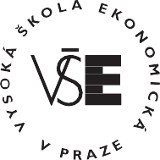
Prague University of Economics and Business

Curriculum Vitae

Personal data

Ing. Michal Mec, 4. March 1995

Education

2020 Ing. VŠE, Faculty of Economics

Economics and Economic administration

(Economic analysis)

2018 Bc. VŠE, Faculty of Economics

Economics and Economic administration

(Public administration and regional development)

Professional Experience

2019 - 2023 NN Investment Partners

Quantitative analytic
2023 – Goldman Sachs Asset Management
Quantitative analytic

Grant participation – sucessfully defended and in progress

2021–2022 Evolution of the share of wage on GDP in coverging economy (IG506030)

2022–2023 Reasons for colorectal cancer screening avoidance (IG506021)

2022– Cautious savings and negative natural interest rate (IG506042)

2023– Impact of emotions on donations to dog shelters(IG506083)

